

**My VA**

Last updated: March 2022

My VA Product Guide

Product overview 4

User access 4

The Master Person Index (MPI) 4

Users who have not verified their identity (LOA1) 4

Users who have verified their identity (LOA3) 6

Navigation 7

Functionality 13

Navigation to profile 13

Disability rating 13

Major issues and error messages 16

Claims and appeals 16

Functionality 17

User has active claims or appeals: Update in the last 30 days 17

User has active claims or appeals: No update in the last 30 days 19

User has no active claims or appeals 20

Major issues and error messages 20

Can’t load claims or appeals with no known time for when the feature will be back 20

Can’t load claims or appeals with known time for when the feature will be back 21

Health care 21

Functionality 22

Appointments 22

Appointments: Has no appointments in the next 30 days or has no upcoming appointments scheduled 23

Messages 24

Messages: Has unread messages 24

Messages: Has no unread messages, but has sent/received messages in the past 24

Messages: Has no unread messages, is not currently using the messaging tool 25

Prescriptions 26

Other links 26

Major issues and error messages 28

We can’t connect to the health care endpoint 28

We can’t connect to the appointments endpoint 28

Cerner alert 28

Benefit payments and debts 29

Functionality 30

Payments 30

Payments: Has recently received a payment 30

Payments: Has not received any payments in the last 30 days 31

Debts 31

Debts: Has outstanding debts 31

Debts: Has no outstanding debts 31

Direct deposit 32

Major issues and error messages 32

We can’t connect to the payments endpoint 32

We can’t connect to the debt endpoint 33

Apply for VA benefits 33

Applications in progress 35

Explore VA benefits and health care 35

Functionality 36

Apply for VA benefits: What benefits does VA offer? 36

Applications in progress: In-progress applications 37

Applications in progress: No in-progress applications 38

Explore VA benefits and health care: Health care 38

Benefits you might be interested in: Disability compensation 38

Benefits you might be interested in: Education benefits 39

Major issues and error messages 40

Table of Figures 40

# 

# Product overview

The My VA dashboard on VA.gov provides Veterans easier access to critical information in one place. My VA ([www.va.gov/my-va](http://www.va.gov/my-va)) allows Veterans to view a summary of important information about themselves, including:

* Disability rating
* Claim and appeals
* Health care
* Benefit payments and debts
* Apply for VA benefits

If users are looking for more information in each of these categories, or wish to make edits to information they see, they can dive further into each section using the links provided.

# User access

For a user to view the My VA dashboard, they must meet the following criteria:

* Be logged in to VA.gov.
* Be in the Master Person Index (MPI).
* Have verified their identity on VA.gov.

## The Master Person Index (MPI)

Veterans found in the Master Person Index (MPI) will have access to My VA on VA.gov if they are logged in and have verified their identity. To be in the MPI, a person must have had an interaction with VA where their data was entered into the MPI system. In most cases, this happens when a person contacts a VA call center.

## Users who have not verified their identity (LOA1)

If someone is logged in and exists in the MPI but has not verified their identity on VA.gov, they will only see the Apply for VA benefits section of My VA when they go to [www.va.gov/my-va](http://www.va.gov/my-va) (Figure 1). From there, they can add additional security to their account by verifying their identity or adding 2-factor authentication (2FA). To view their disability rating (if applicable), claims or appeals information (if applicable), or health care information (if applicable), they must verify their identity ([https://va.gov/verify/](https://staging.va.gov/verify/)).

**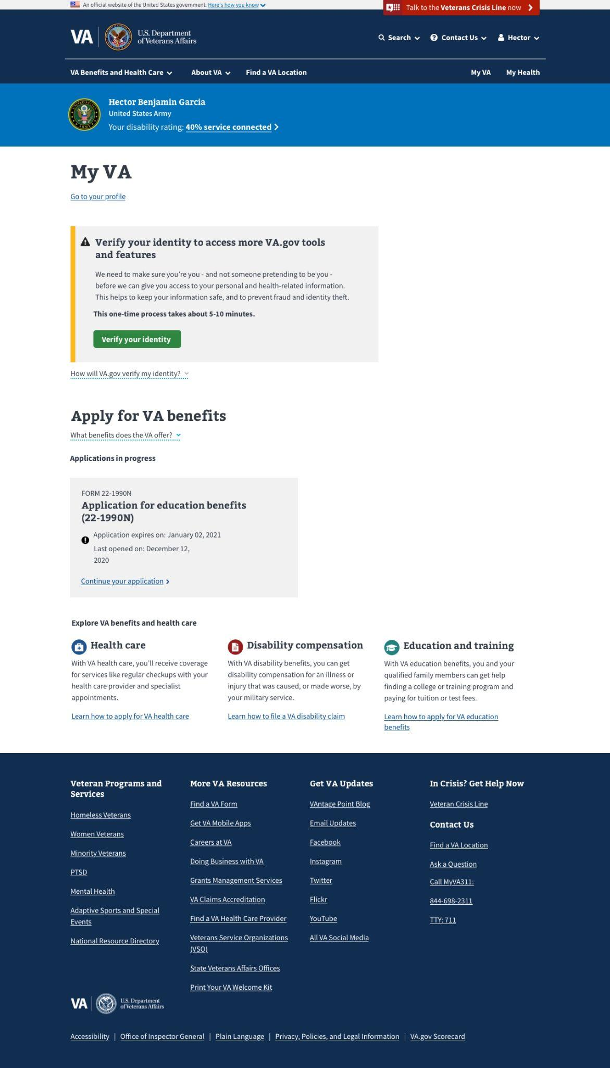***Figure 1. What an LOA1 user sees at My VA.*

## Users who have verified their identity (LOA3)

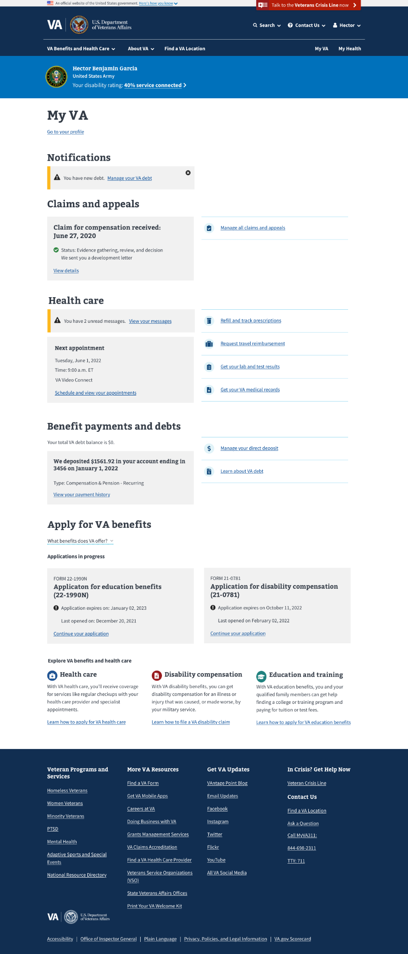  
*Figure 2. The full My VA dashboard.*

Users who are logged in, exist in the MPI, and have verified their identity (LOA3) will be able to view their full My VA dashboard (Figure 2), though sections may vary depending on the user’s personal circumstances.

# **Navigation**

Users can navigate to the My VA dashboard through two main paths.

**Path 1: Sign in and navigate to My VA dashboard via personalized menu**

To navigate to the My VA dashboard, users must:

1. Sign into VA.gov (Figure 3).

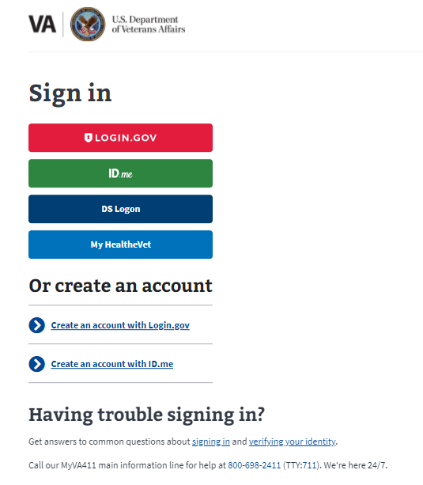  
*Figure 3. VA.gov sign-in page.*

1. Click the personalized menu in the upper right corner of the screen (the user’s name; Figure 4) and select My VAfrom the drop-down menu.

**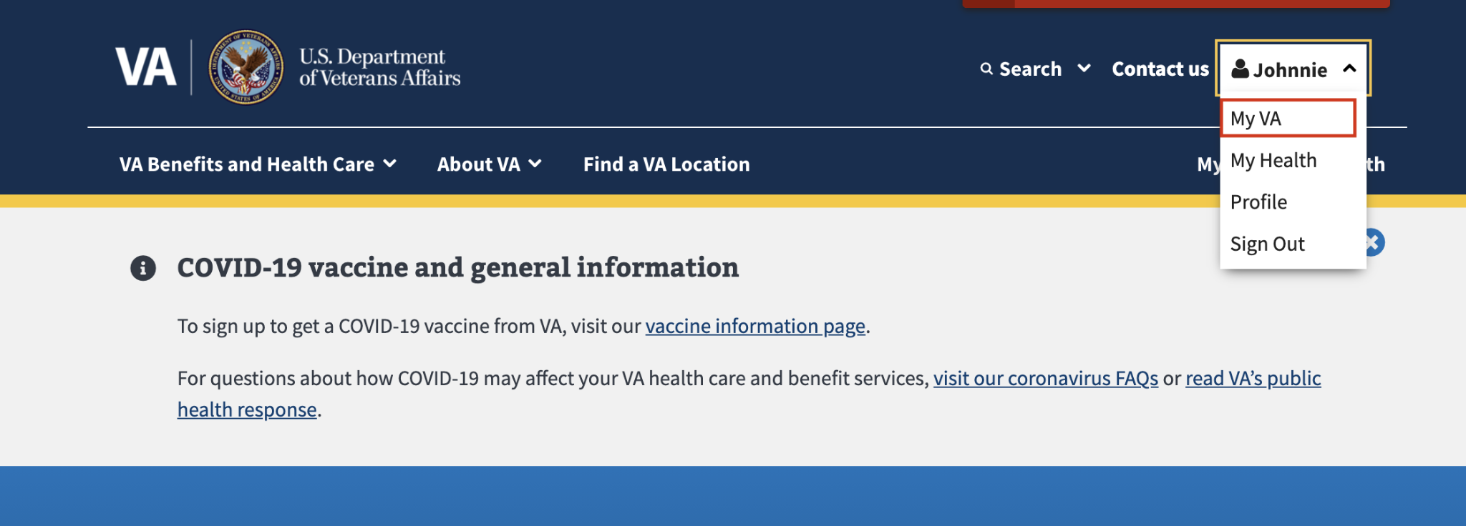***Figure 4. Personalized user menu.*

This will take logged in users to the My VA dashboard. As mentioned above, if a user is LOA3, they will be able to view their full My VA dashboard and whatever sections apply to them (disability rating, claims and appeals, health care, benefit payments and debts). All users will be able to see the Apply for VA benefits section, regardless of their LOA status. See Figure 5.

  
*Figure 5. My VA dashboard as seen by LOA3 user.*

If a user is LOA1, then they will see the screen below (Figure 6). They will need to verify their identity before they can access any other features on My VA ([https://va.gov/verify/](https://staging.va.gov/verify/)).

*****Figure 6. LOA1 user My VA dashboard.*

**Path 2: Main navigation**

Users can alsonavigate directly to the My VA dashboard from the homepage. To navigate to the My VA dashboard, users must:

1. Click My VA, which is displayed immediately below the sign-in button in the upper right corner of the screen (Figure 7). This will automatically redirect the user to the sign-in page.

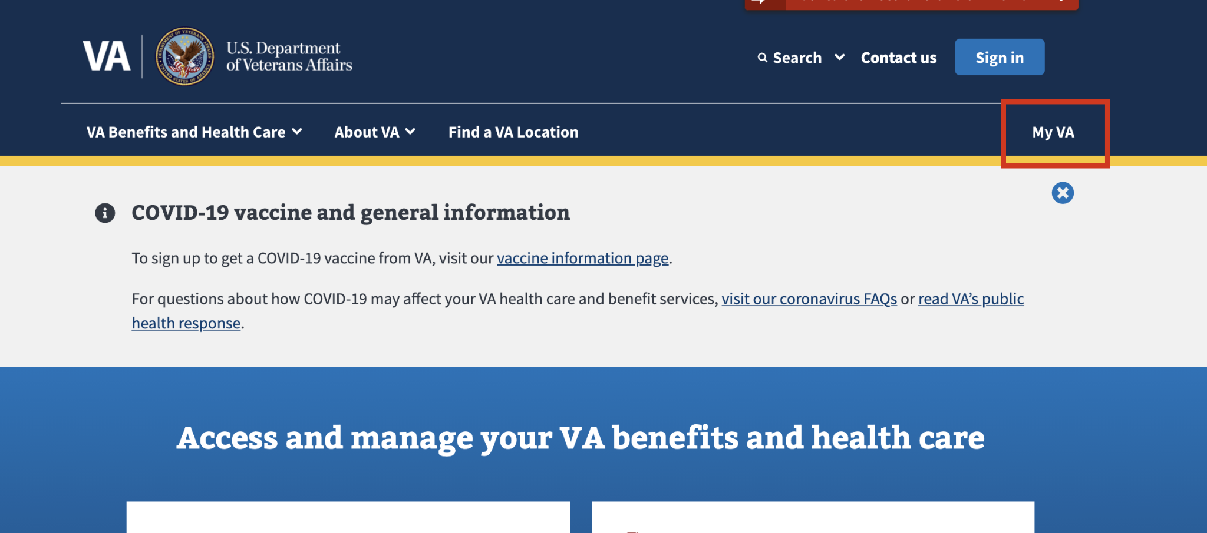  
*Figure 7. The clickable My VA link.*

1. If users are not signed in, they will be prompted to sign in to VA.gov (Figure 8).

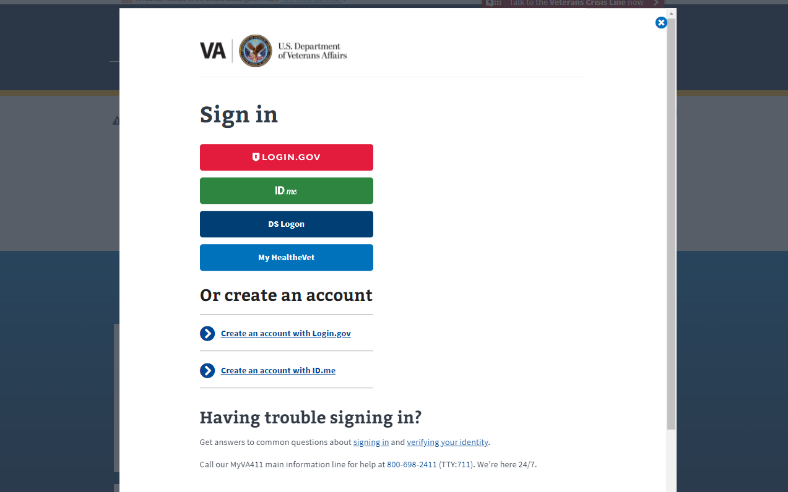*Figure 8. Login prompt.*

After signing in, or if a user is already signed in, they will be taken to the My VA dashboard.

# **Functionality**

#### Navigation to profile

At the top of the page, users can quickly navigate to their profile by clicking the link “Go to your profile” ([https://va.gov/profile](https://staging.va.gov/profile)). See Figure 9.

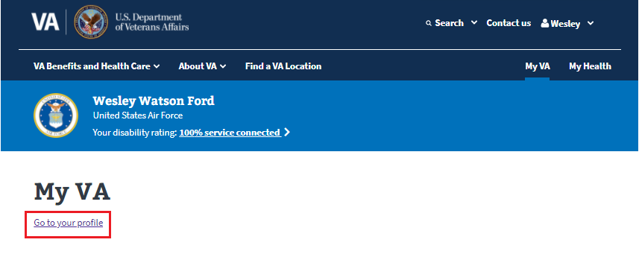  
*Figure 9. Go to your profile link.*

## Disability rating

The disability rating is in the blue banner which appears below the main navigation (Figure 10). The blue banner shows:

* Name
* Branch of service
* Disability Rating (if applicable)

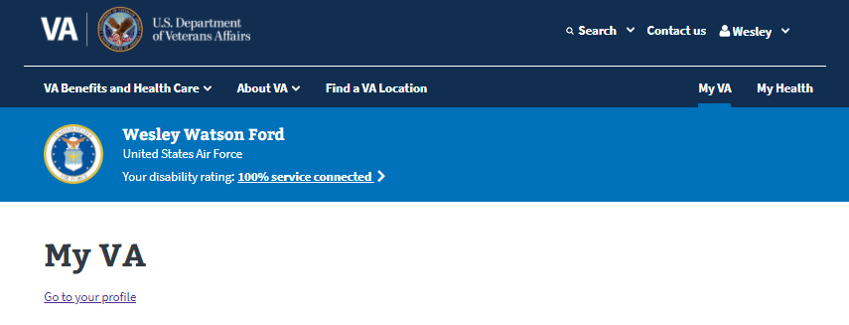  
*Figure 10. Veteran disability rating.*

The disability rating is displayed as a percentage value below the branch of service. It links to the disability rating overview page, as shown in Figure 11 (<https://va.gov/disability/view-disability-rating/rating>).

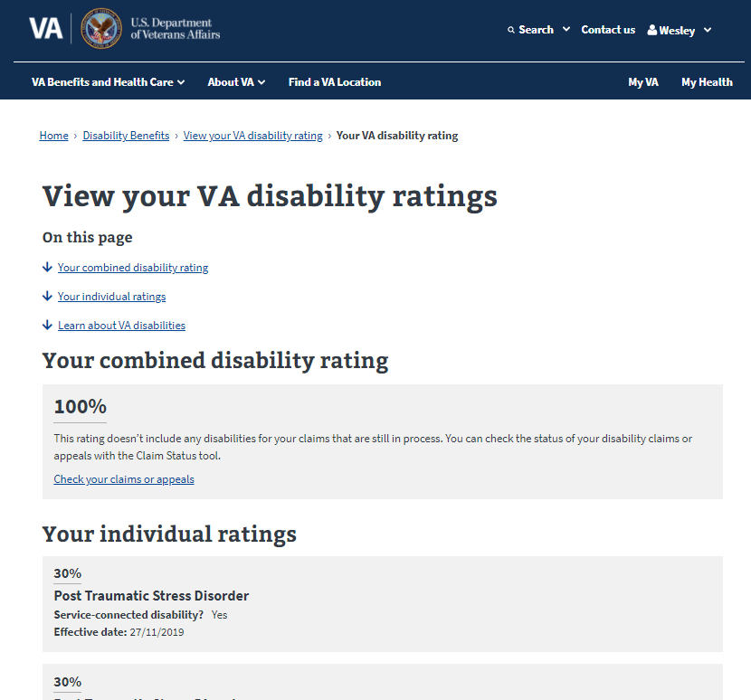  
*Figure 11. Percentage value of combined disability rating.*

If the user does not have a disability rating, then only their name and branch of service appears in the blue banner (see Figure 12).

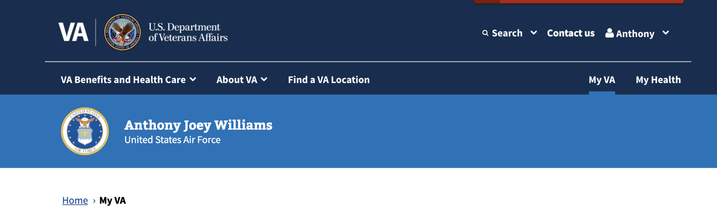  
*Figure 12. User has no disability rating.*

### Major issues and error messages

If we are unable to retrieve the disability rating for a user that has a disability rating, we will only display the link to the disability rating overview page (<https://va.gov/disability/view-disability-rating/rating>), as shown in Figure 13.

  
*Figure 13. With only the disability link displayed.*

## Claims and appeals

The claims and appeals section (Figure 14) allows users to see their latest claim update (if applicable) and easily get to the claims and appeals tool on VA.gov.

The claims and appeals section will only show on the My VA dashboard for a user if the user has active claims or appeals. This section will include:

* The most recent claim update in the last 30 days
* A link to manage all claims and appeals ([https://va.gov/claim-or-appeal-status/](https://staging.va.gov/claim-or-appeal-status/))

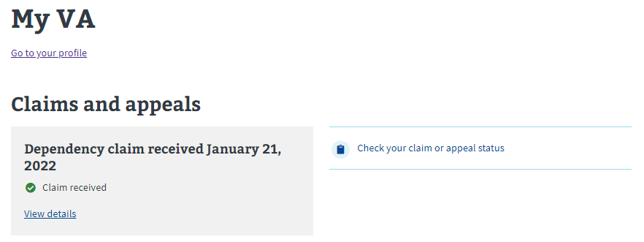  
*Figure 14. Claims and appeals.*

This section will not show if:

* A user has never filed a claim or appeal.
* A user has filed at least 1 claim or appeal, but all claims and appeals have been closed for more than 30 days.

### Functionality

#### User has active claims or appeals: Update in the last 30 days

If a user has active claims, and there has been an update in the last 30 days, there will be a grey box with the latest claim and status. There will also be a link to view the details of that claim. If the user clicks on the link that reads “View details,” it will take them to the breakdown of that specific claim. See Figure 15.

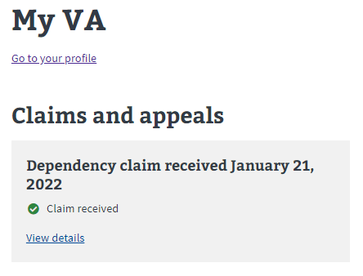  
*Figure 15. User has active claims or appeals.*

If a user wants to manage or view all their claims or appeals, they’ll need to do so from the claims and appeals tool (Figure 16). They can get to the tool by clicking on “Manage all your claims and appeals” ([https://va.gov/claim-or-appeal-status/](https://staging.va.gov/claim-or-appeal-status/)).

*****Figure 16. The claims and appeals tool.*

#### User has active claims or appeals: No update in the last 30 days

If a user has active claims or appeals, and there has not been an update in the last 30 days, there will be messaging stating that there have been no updates in the last 30 days (Figure 17).

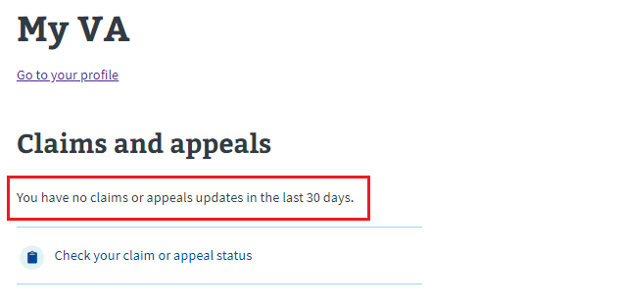  
*Figure 17. No claims or appeals updates in the past 30 days.*

If a user wants to manage or view all their claims or appeals, they’ll need to do so from the claims and appeals tool. They can get to the tool by clicking on the link that reads “Check your claim or appeal status” ([https://va.gov/claim-or-appeal-status/](https://staging.va.gov/claim-or-appeal-status/)). See   
Figure 18.

**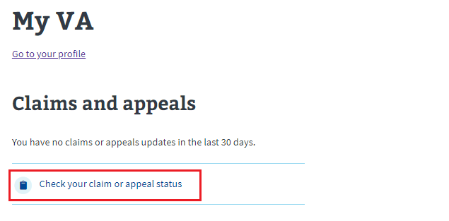***Figure 18. Check your claims or appeal status.*

#### User has no active claims or appeals

If a user’s claims or appeals have all been closed, or if a user has never filed a claim or appeal, then this section will not be visible (see Figure 19).

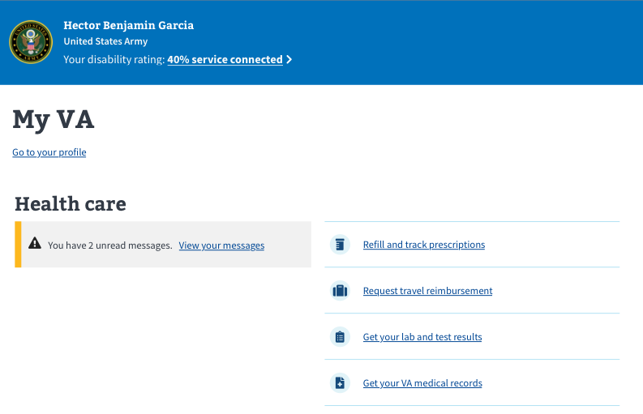  
*Figure 19. No active claims or appeals.*

### Major issues and error messages

#### Can’t load claims or appeals with no known time for when the feature will be back

If we can’t connect to the claims or appeals endpoint and there is no known time for when the feature will be back, this error will show in place of the claims and appeals section (Figure 20).

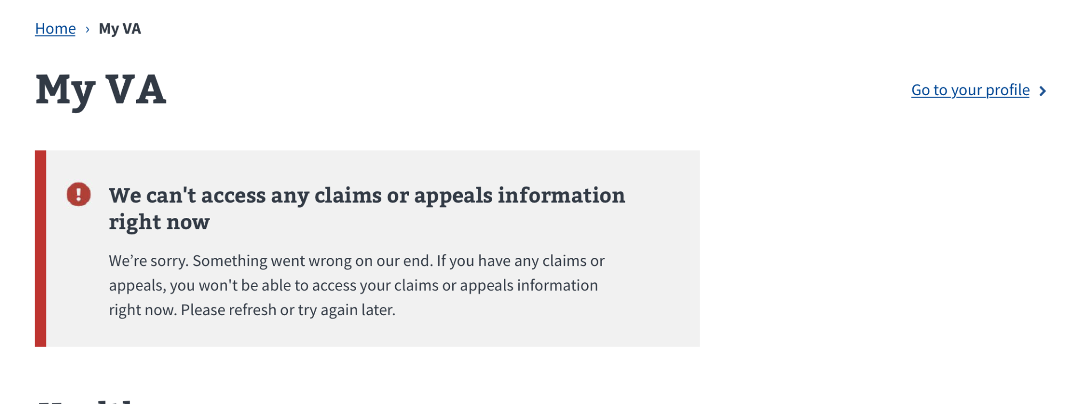  
*Figure 20. Can’t load claims or appeals error, no known resolution time.*

#### Can’t load claims or appeals with known time for when the feature will be back

If we can’t connect to the claims or appeals endpoint, but we know when the feature will be back up and running (e.g., planned downtime), this error (Figure 21) will show in place of the claims and appeals section.

**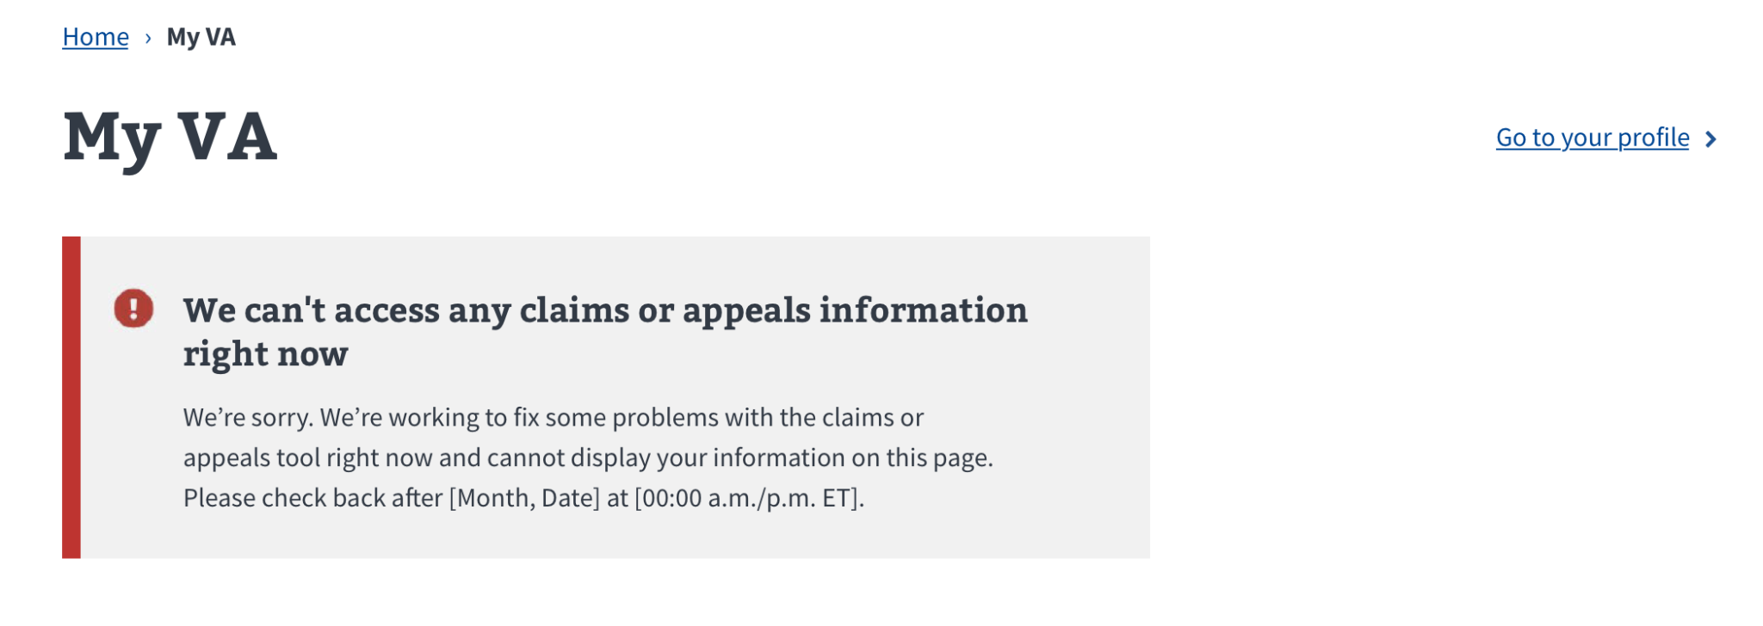***Figure 21. Information error with known resolution time.*

## Health care

The health care section (Figure 22) allows users to quickly access their health care tools as well as view their next appointment (if applicable). This section will only show on a user’s My VA dashboard if they are enrolled in VA health care. The health care section includes:

* Next appointment (if applicable)
* Schedule and view your appointments (<https://va.gov/health-care/schedule-view-va-appointments/appointments>)
* A link stating how many unread messages a user has or to send a secure message to your health care team (<https://sqa.eauth.va.gov/mhv-portal-web/eauth?deeplinking=secure_messaging>)
* A link to refill or track prescriptions (<https://sqa.eauth.va.gov/mhv-portal-web/eauth?deeplinking=prescription_refill>)
* A link to get your lab and test results (<https://sqa.eauth.va.gov/mhv-portal-web/eauth?deeplinking=download_my_data>)
* A link to get your VA medical records (<https://sqa.eauth.va.gov/mhv-portal-web/eauth?deeplinking=download_my_data>)

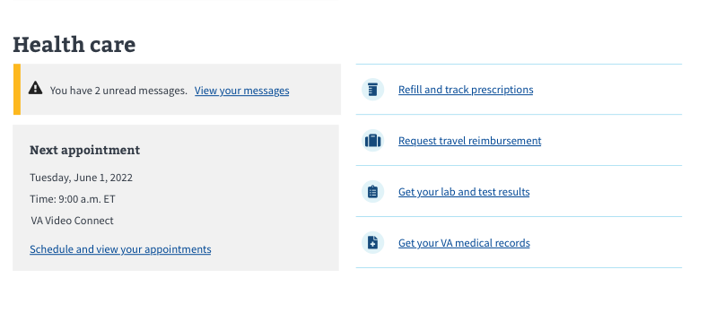  
*Figure 22. Health care section.*

If the user is not enrolled in health care, then this section will not show on the   
My VA dashboard.

### Functionality

#### Appointments

The appointments section will show within the health care section, but it might look different for some users depending on whether they have upcoming appointments.

**Appointments: Has appointments**

If a user has confirmed upcoming appointments, then the next appointment will be displayed in a grey box (Figure 23). This box includes date, time, location, and a link to schedule and view your appointments. (<https://va.gov/health-care/schedule-view-va-appointments/appointments>)

If a user wants to manage or schedule appointments online, they’ll need to do it from the appointments tool. They can get to the tool by clicking on “Schedule and view   
your appointments.”

**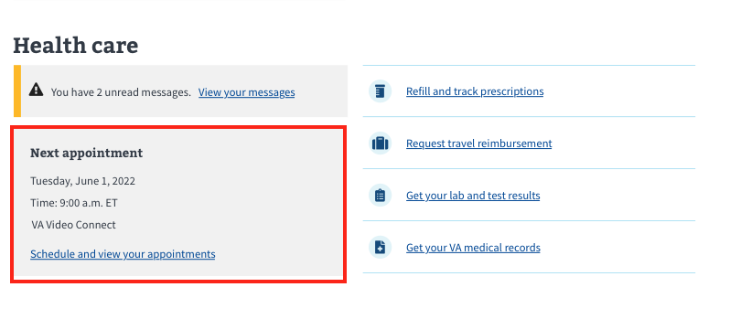***Figure 23. Health care appointment box.*

#### Appointments: Has no appointments in the next 30 days or has no upcoming appointments scheduled

If a user has no upcoming appointments within the next 30 days or no upcoming appointments scheduled, then the grey box described above will not display. Instead, there will be messaging stating that there are no upcoming appointments in the next 30 days and a link to schedule and view your appointments (<https://va.gov/health-care/schedule-view-va-appointments/appointments>). See Figure 24.

**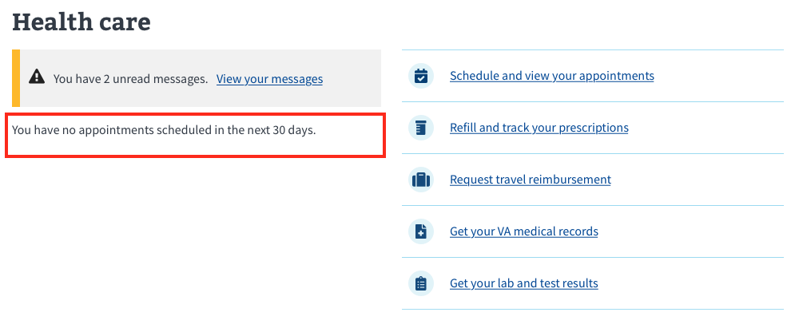***Figure 24. Health care section with no upcoming appointments listed.*

If a user wants to manage or schedule appointments online, they’ll need to do it from the appointments tool. They can get to the tool by clicking on the “Schedule and view your appointments” link.

#### Messages

The messages section is always displayed within the health care section, but it might look different for some users depending on whether they have unread messages.

#### Messages: Has unread messages

If a user has unread messages, then they will see a text statement and bolded link that reads “You have n unread messages. View your messages.” (<https://sqa.eauth.va.gov/mhv-portal-web/eauth?deeplinking=secure_messaging>), as shown in Figure 25 below, where X is the number of unread messages that the user currently has.

If a user wants to manage their messages online, they’ll need to do it from the secure messaging tool. They can get to the secure messaging tool by clicking on the link that reads “View your messages.”

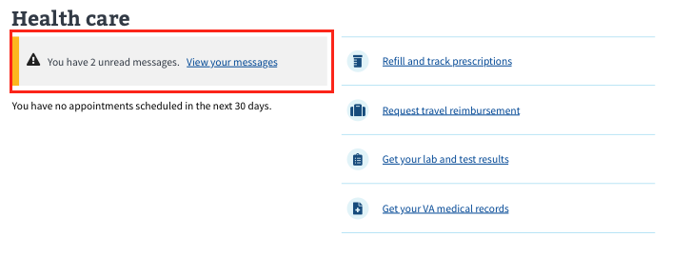*Figure 25. Number of unread messages waiting.*

#### Messages: Has no unread messages, but has sent/received messages in the past

If a user has no unread messages, but they are eligible to send and receive messages then they will see a text statement and bolded link that reads “You have 0 unread messages. View your messages” (<https://sqa.eauth.va.gov/mhv-portal-web/eauth?deeplinking=secure_messaging>). See Figure 26.

If a user wants to manage their messages online, they’ll need to do it from the secure messaging tool. They can get to the secure messaging tool by clicking on the link that reads “View your messages.”

**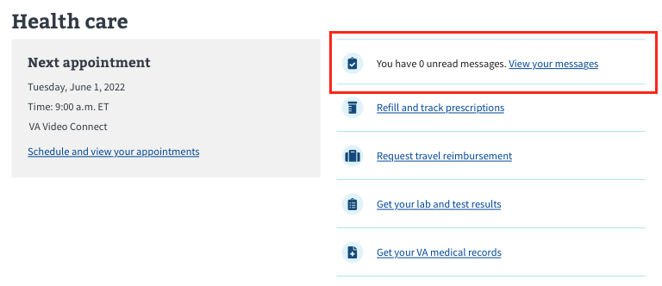***Figure 26. No unread messages.*

#### Messages: Has no unread messages, is not currently using the messaging tool

If a user has never used the messaging tool they will see a link that says “Send a secure message to your health care team” (<https://sqa.eauth.va.gov/mhv-portal-web/eauth?deeplinking=secure_messaging>). See Figure 27 below.

If a user wants to manage their messages online, they’ll need to do it from the secure messaging tool. They can get to the secure messaging tool by clicking on the link that reads “Send a secure message to your health care team”(<https://sqa.eauth.va.gov/mhv-portal-web/eauth?deeplinking=secure_messaging>).

**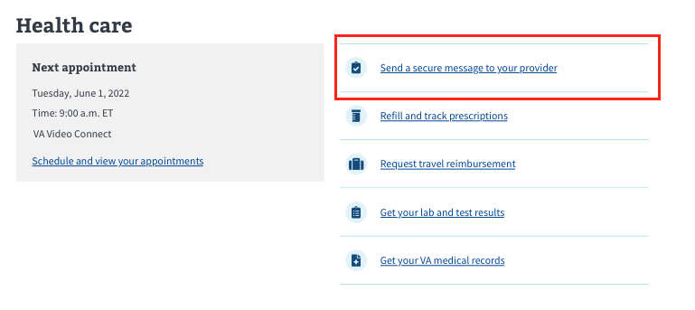***Figure 27. Sending a secure message to a user’s health care team link.*

#### Prescriptions

The prescriptions section will always show within the health care section. If a user wants to manage their prescriptions online, they’ll need to do it from the prescriptions tool. To get to the prescriptions tool, they can click on the link that reads “Refill and track your prescriptions” (<https://sqa.eauth.va.gov/mhv-portal-web/eauth?deeplinking=prescription_refill>). See Figure 28.

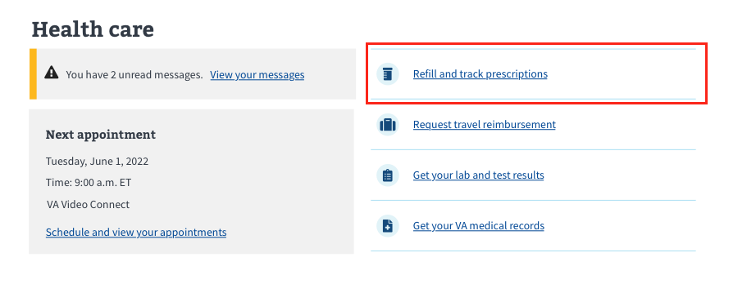  
*Figure 28. The prescriptions link.*

#### Other links

If a user wants to request travel reimbursement, they can click the link that reads “Request travel reimbursement”

(<https://www.va.gov/health-care/get-reimbursed-for-travel-pay/>), as shown in Figure 29.

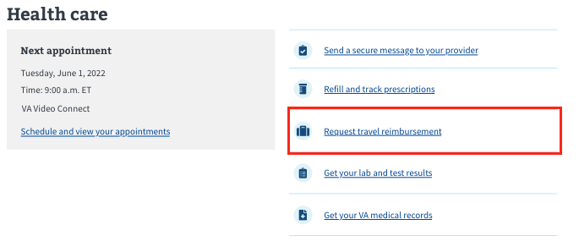  
*Figure 29. The travel reimbursement link.*

If a user wants to view their lab and test results, they can click on the link that reads “Get your lab and test results” (<https://sqa.eauth.va.gov/mhv-portal-web/eauth?deeplinking=download_my_data>), as shown in Figure 30.

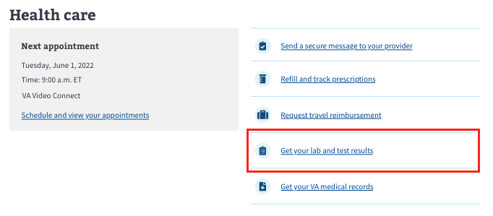  
*Figure 30. Lab and test results link.*

If a user wants to go to their medical records, they can click on the link that reads “Get your VA medical records” (<https://sqa.eauth.va.gov/mhv-portal-web/eauth?deeplinking=download_my_data>). See Figure 31.

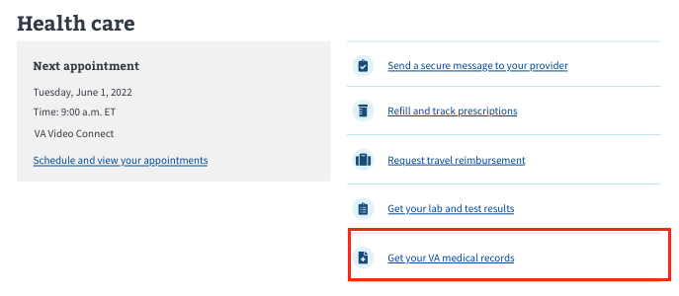  
*Figure 31. View VA medical records.*

### Major issues and error messages

#### We can’t connect to the health care endpoint

If we are unable to detect whether someone has health care because we are unable to connect to the endpoint, the user will see an error at the top of the page and the health care section will not load. See Figure 32.

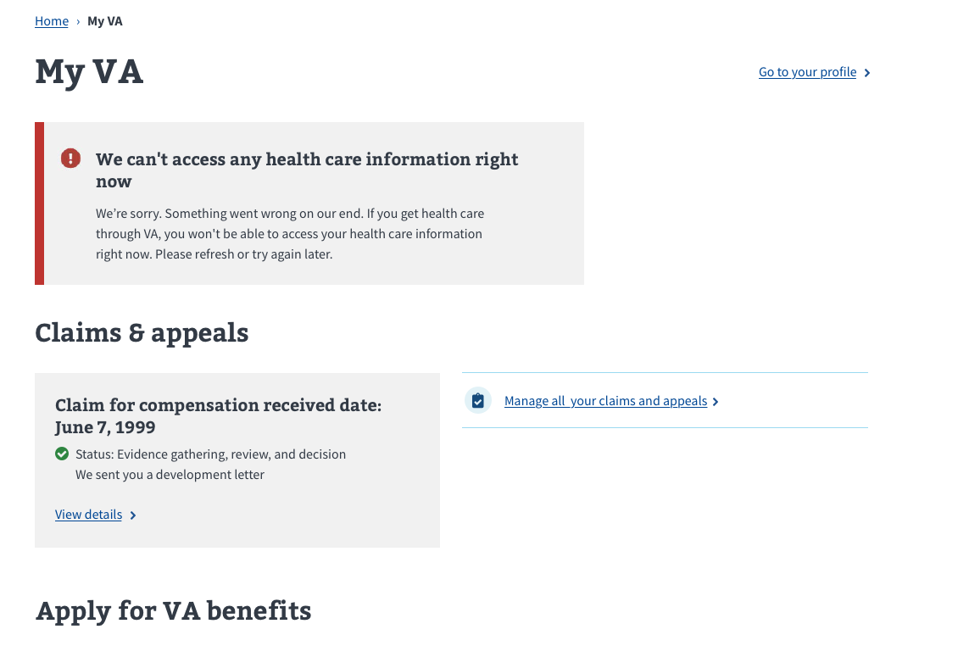  
*Figure 32. Unable to access health care information.*

#### We can’t connect to the appointments endpoint

If we are unable to detect whether someone has upcoming appointments because we are unable to connect to the appointments endpoint, the user will see the following error message (Figure 33):

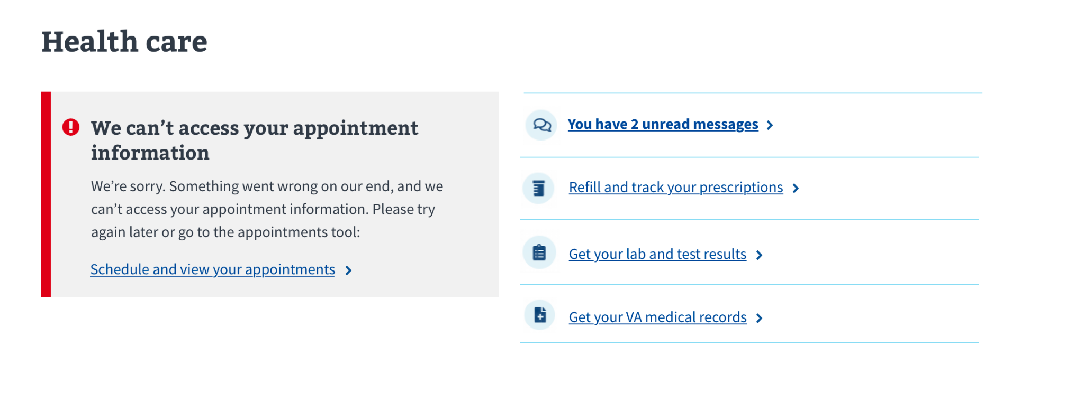  
*Figure 33. Can’t access appointment information.*

#### Cerner alert

If we detect a user’s appointments, messages, or prescriptions are managed at a Cerner facility, then the user will see the following alert instead of the health care section (Figure 34):

**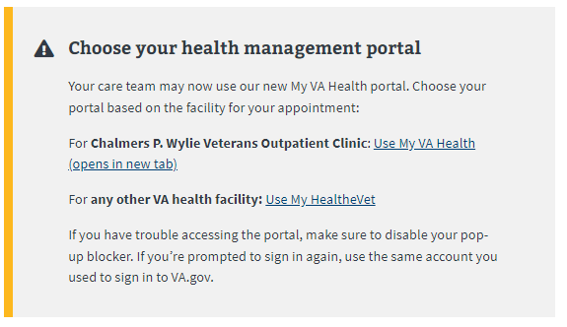***Figure 34. Veteran’s appointments, messages, et al, are managed at a Cerner facility.*

## Benefit payments and debts

The benefit payments and debts section (Figure 35) allows users to see their latest payment from VA (if applicable); number of outstanding debts (if applicable); view their payment history; and provide access to manage their debts and easily access their direct deposit information on their VA.gov profile.

The benefit payments and debts section will only show on the My VA dashboard if the user has ever received a payment (compensation, pension, or education funds) from VA. This section will include:

* Information about the most recent payment received from VA in the last 30 days, including the date, amount, the last 4 digits of the account number, and the payment type
* The number of outstanding debts and a link to manage their debts ([https://va.gov/manage-va-debt/your-debt/](https://staging.va.gov/claim-or-appeal-status/))
* A link to view the payment history ([https://va.gov/va-payment-history/payments/](https://staging.va.gov/claim-or-appeal-status/))
* A link to manage the direct deposit ([https://va.gov/profile/direct-deposit/](https://staging.va.gov/claim-or-appeal-status/))

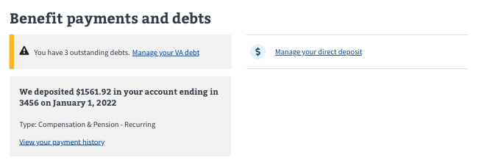

*Figure 35. The benefit payments and debts section.*

If the user has never received payments from VA, then this section will not show on the My VA dashboard.

### Functionality

#### Payments

The payments card will show within the benefit payments and debts section, but it might look different for some users depending on whether they have recently received payments from VA.

#### Payments: Has recently received a payment

If a user has received a payment within the last 30 days, then the payment information will be displayed in a grey box (Figure 36). This box includes payment amount and last 4 digits of a direct deposit account or will indicate payment was made by check (whichever is applicable). It also includes payment date, type of payment, and a link to view payment history (<https://va.gov/va-payment-history/payments>).

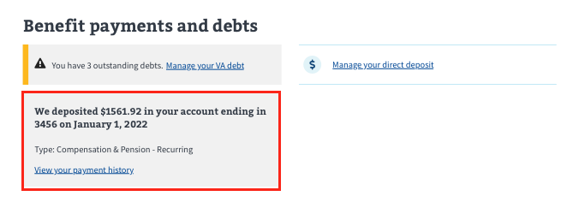*Figure 36. Payment box.*

#### Payments: Has not received any payments in the last 30 days

If a user has not received any payments from VA in the last 30 days, then the payment information box described above will not display. Instead, there will be messaging stating that no payments have been received in the last 30 days and a link to view payment history (<https://va.gov/va-payment-history/payments>). See Figure 37.

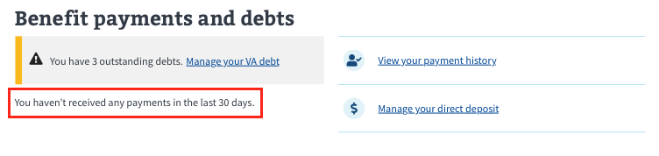*Figure 37. Veteran has not received any payments in the last 30 days.*

#### Debts

The debts notification will show within the benefit payments and debts section, but it might look different for some users depending on whether there are outstanding debts owed to VA.

#### Debts: Has outstanding debts

If a user has outstanding debts, then they will see a notification box with a text statement and bolded link that reads “You have [#] outstanding debts. Manage your VA debt” (<https://va.gov/manage-va-debt/your-debt>), as shown in Figure 38 below, where [#] is the number of debts that the user has.

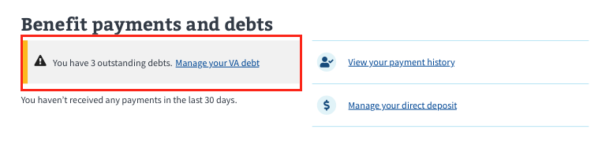

#### *Figure 38. Outstanding debt notification box.*

#### Debts: Has no outstanding debts

If a user has no outstanding debts owed to VA, then the debt notification box described above will not display. Instead, there will be messaging stating that the total VA debt balance is $0, with a link to learn more about VA debt (<https://va.gov/va-payment-history/payments>). See Figure 39.

#### *Figure 39. Veteran has no outstanding debt.*

#### Direct deposit

If a user wants to view their direct deposit information, they can click on the link that reads “Manage your direct deposit” (<https://va.gov/profile/direct-deposit>), as shown in Figure 40.

**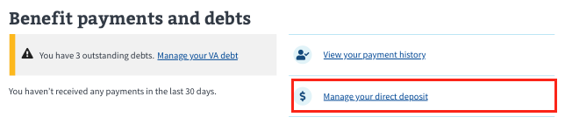***Figure 40. Manage your direct deposit.*

### Major issues and error messages

#### We can’t connect to the payments endpoint

If we are unable to detect whether the user has recently received a payment because we are unable to connect to the endpoint, they will see an error under the benefit payments and debts section header. See Figure 41.

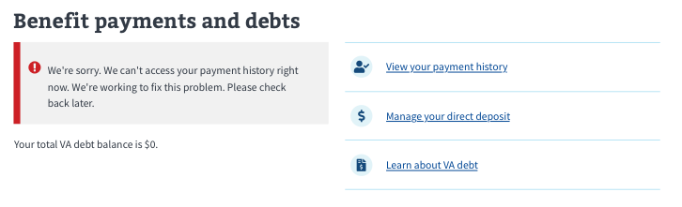  
*Figure 41. Unable to access payment information.*

#### We can’t connect to the debt endpoint

If we are unable to detect whether the user has outstanding debts because we are unable to connect to the endpoint, they will see an error under the benefit payments and debts section header. See Figure 42.

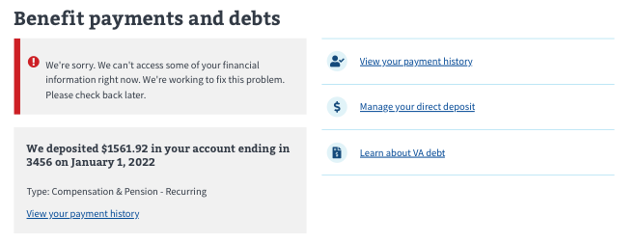  
*Figure 42. Unable to access debt information.*

## Apply for VA benefits

The apply for VA benefitssection will always show on a user’s My VA dashboard. This section is divided into 2 parts (see Figure 43).

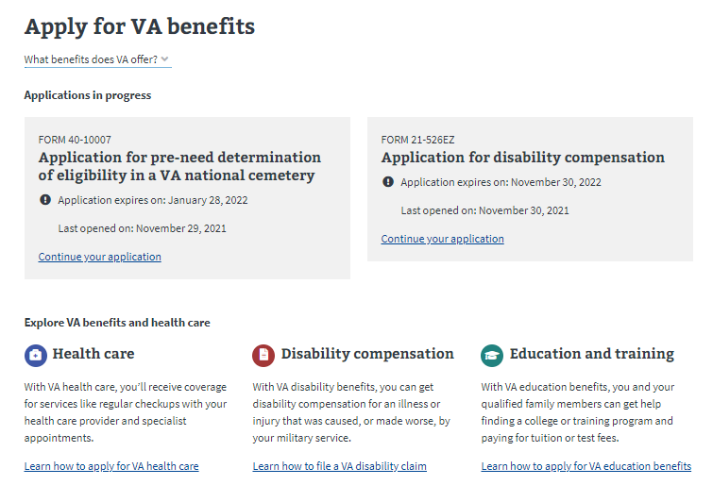*Figure 43. The 2-part apply for VA benefits section.*

### Applications in progress

Any online application that a user has started but has not submitted will be shown in this section (Figure 44) on VA.gov. Please note, this will not show any applications that may have been started or submitted via paper or outside of VA.gov.

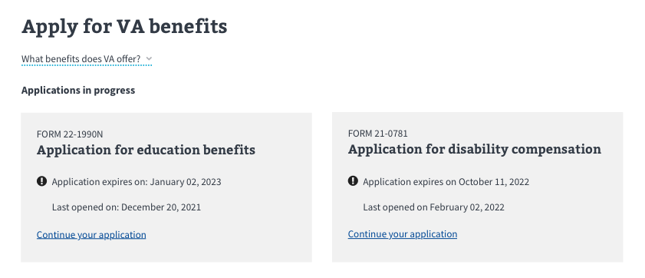  
*Figure 44. Benefits applications in progress.*

### Explore VA benefits and health care The following information appears in Figure 45:

* A short paragraph of information about VA health care and a link to learn how to apply for VA health care (<https://va.gov/health-care/how-to-apply/>)
* A short paragraph of information about disability compensation and a link to learn how to file a VA disability claim (<https://va.gov/disability/how-to-file-claim/>)
* A short paragraph of information about education benefits and a link to learn how to apply for VA education benefits ([https://va.gov/education/how-to-apply/](https://staging.va.gov/education/how-to-apply/))

*Figure 45. Explore VA benefits and health care.*

### Functionality

#### Apply for VA benefits: What benefits does VA offer?

If a user has questions about VA benefits, they can click on the link that reads “What benefits does VA offer?” Clicking that link exposes a list of benefits offered and where users can learn more. See Figure 46.

* Health care (<https://va.gov/health-care/>)
* Education and training (<https://va.gov/education/>)
* Disability compensation (<https://va.gov/disability/>)
* Careers and employment (<https://va.gov/careers-employment/>)
* Pension (<https://va.gov/pension/>)
* Housing assistance (<https://va.gov/housing-assistance/>)
* Burials and memorials (<https://va.gov/burials-memorials/>)
* Life insurance (<https://va.gov/life-insurance/>)
* Service member benefits (<https://va.gov/service-member-benefits/>)
* Family member benefits (<https://va.gov/family-member-benefits/>)

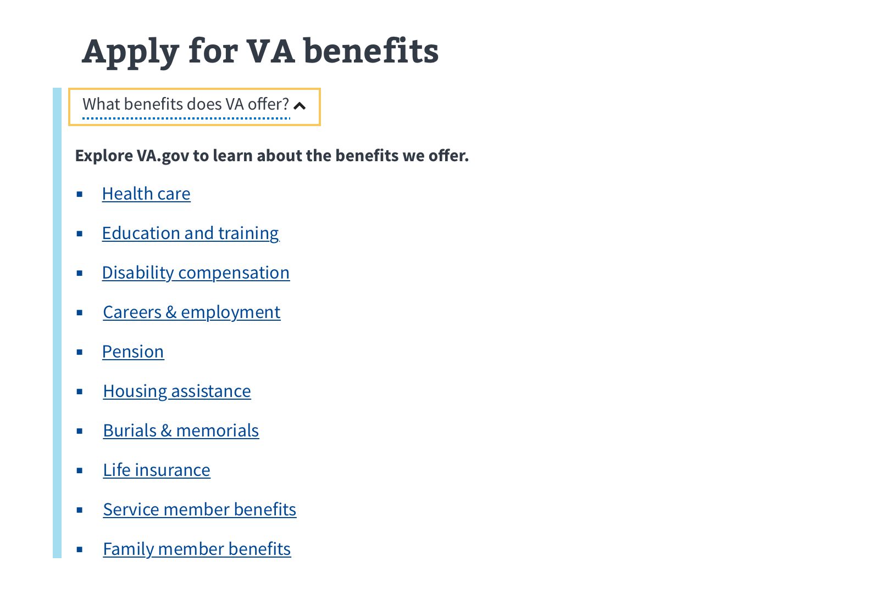  
*Figure 46. Benefits FAQ information.*

#### Applications in progress: In-progress applications

If a user starts and saves an application but does not submit it, they will see the application in the applications in progress section of the apply for VA benefits section (Figure 47).

*Figure 47. Unsubmitted applications in progress.*

#### Applications in progress: No in-progress applications

If a user does not have any in-progress applications, they will see a message stating they have no benefit applications in progress (see Figure 48).

**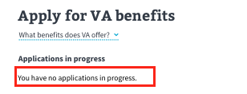***Figure 48. No in-progress applications.*

#### Explore VA benefits and health care: Health care

The health care informational block and link will show on a user’s My VA dashboard, regardless of whether they are currently receiving health care (Figure 49). If a user wants to learn how to apply for VA health care, they can click on the “Learn how to apply for VA health care” link (<https://va.gov/health-care/how-to-apply/>).

**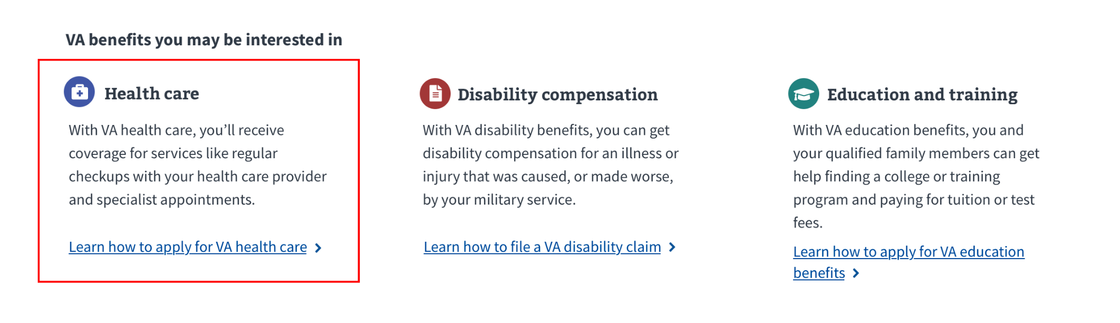***Figure 49. Health care block is always visible.*

#### Benefits you might be interested in: Disability compensation

The disability compensation informational block and link will always show on a user’s My VA dashboard, regardless of whether they are currently receiving compensation (Figure 50). If a user wants to learn how to file a disability compensation claim, they can click on the“Learn how to file a VA disability claim” link.

*****Figure 50. Disability compensation block is always visible.*

#### Benefits you might be interested in: Education benefits

The education benefits informational block and link will show on their My VA dashboard, regardless of whether they are receiving payments for education benefits (Figure 51). If a user wants to learn how to start an education benefits application, they can click on the “Learn how to apply for VA education benefits” link   
([https://va.gov/education/how-to-apply/](https://staging.va.gov/education/how-to-apply/)).

**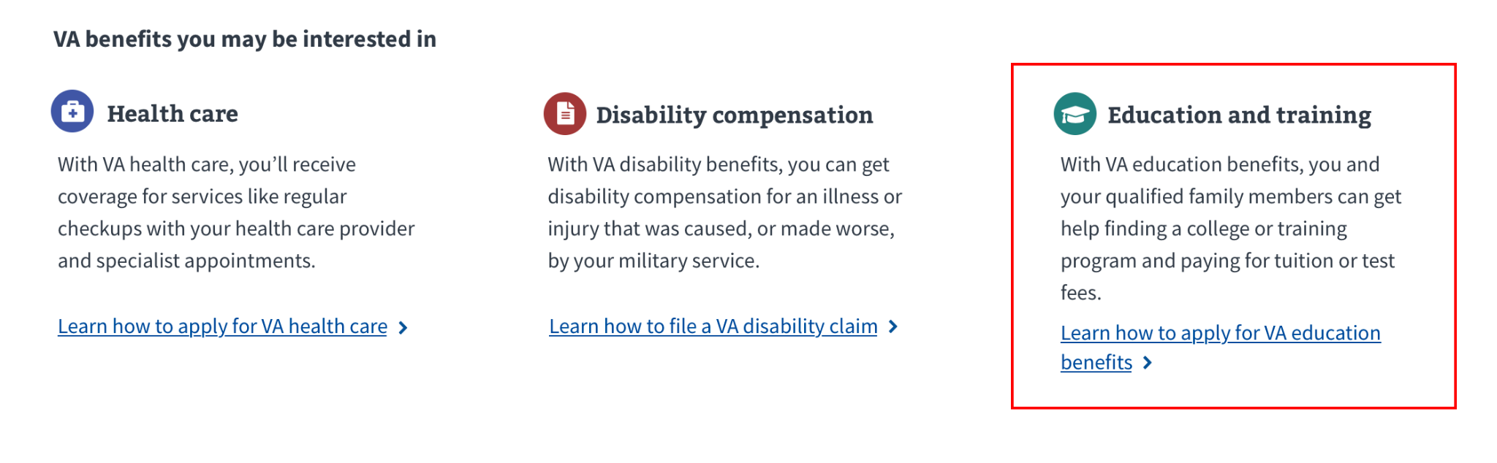***Figure 51. Education and training block is always visible.*

### Major issues and error messages

There are no major issues or error messages for this section of My VA.

**Table of Figures**

*Figure 1. What an LOA1 user sees at My VA**.*  
*Figure 2. The full My VA dashboard.**Figure 3. VA.gov sign-in page.**Figure 4. Personalized user menu.**Figure 5. My VA dashboard as seen by LOA3 user.**Figure 6. LOA1 user My VA dashboard.**Figure 7. The clickable My VA link.**Figure 8. Login prompt.**Figure 9. Go to your profile link.**Figure 10. Veteran disability rating.**Figure 11. Percentage value of combined disability rating.**Figure 12. User has no disability rating.**Figure 13. With only the disability link displayed.**Figure 14. Claims and appeals.**Figure 15. User has active claims or appeals.**Figure 16. The claims and appeals tool.**Figure 17. No claims or appeals updates in the past 30 days.**Figure 18. Check your claims or appeal status.**Figure 19. No active claims or appeals.**Figure 20. Can’t load claims or appeals error, no known resolution time.**Figure 21. Information error with known resolution time.**Figure 22. Health care section.**Figure 23. Health care appointment box.**Figure 24. Health care section with no upcoming appointments listed.**Figure 25. Number of unread messages waiting.**Figure 26. No unread messages.**Figure 27. Sending a secure message to a user’s health care team link.**Figure 28. The prescriptions link.**Figure 29. The travel reimbursement link**.**Figure 30. Lab and test results link.**Figure 31. View VA medical records.**Figure 32. Unable to access health care information.**Figure 33. Can’t access appointment information.**Figure 34. Veteran’s appointments, messages, et al, are managed at a Cerner facility.**Figure 35. The benefit payments and debts section.**Figure 36. Payment box.**Figure 37. Veteran has not received any payments in the last 30 days.**Figure 38. Outstanding debt notification box.**Figure 39. Veteran has no outstanding debt.**Figure 40. Manage your direct deposit.**Figure 41. Unable to access payment information.**Figure 42. Unable to access debt information.**Figure 43. The 2-part apply for VA benefits section.**Figure 44. Benefits applications in progress.**Figure 45. Explore VA benefits and health care**.**Figure 46. Benefits FAQ information.**Figure 47. Unsubmitted applications in progress.**Figure 48. No in-progress applications.**Figure 49. Health care block* *is* *always visible.**Figure 50. Disability compensation block is always visible.**Figure 51. Education and training block* *is* *always visible.*